White House Visitor Logs
Shaghayegh Malekshahi
DSC 530 – Data Presentation
Bellevue University

Introduction
This project presents a data-driven visual analysis of historical White House visitor logs with the objective of identifying operational patterns related to visitor volume, space utilization, and timing. The analysis is explicitly non-political and focuses solely on operational and logistical insights that can support more effective planning and resource allocation.
Using multiple monthly datasets from the White House Visitor Logs, this project applies data cleaning, transformation, and visualization techniques in Python to uncover trends in daily visit volume, meeting location concentration, visit size variability, cumulative demand over time, and weekly visitation patterns. The visualizations were designed to communicate insights clearly to operational stakeholders with varying levels of data literacy.
The intended audience for this analysis includes facilities management, scheduling coordinators, and security operations personnel who rely on timely and accurate information to manage staffing and space efficiently. By translating raw visitor data into actionable insights, this project aims to support informed decision-making rather than simply presenting descriptive statistics.
The central recommendation emerging from this analysis is to align staffing and room scheduling strategies with observed peak periods, particularly during high-volume months and late-week activity surges. The findings suggest that visitor demand is unevenly distributed across time and locations, reinforcing the need for adaptive operational planning rather than static scheduling models.

Audience
The intended audience for this analysis is White House operations and facilities management stakeholders, including scheduling coordinators, security operations staff, and administrative leadership. This audience is assumed to have basic data literacy and familiarity with operational metrics such as visit counts, time trends, and capacity planning, but not advanced statistical expertise. Therefore, the visuals emphasize clarity, trends, and comparisons rather than complex modeling.

Purpose and Call to Action
The purpose of this visual story is to identify patterns in visitor volume, timing, and location usage to support more efficient staffing and space planning. The call to action is to adjust staffing levels and room scheduling policies based on observed peak periods, particularly during high-volume months and toward the end of the workweek.

Medium
This story is presented through a combination of Python-generated visualizations and a written narrative, compiled into a document suitable for reporting or presentation. This medium allows stakeholders to quickly interpret trends while also providing written context to support decision-making.

Key Insights from the Visuals
FIGURE 1 — Daily Visit Volume
The Daily Visit Volume line chart shows substantial variability across the selected months, with clear spikes indicating days of unusually high activity. These spikes suggest periods where staffing and security demand may be strained if not proactively managed.
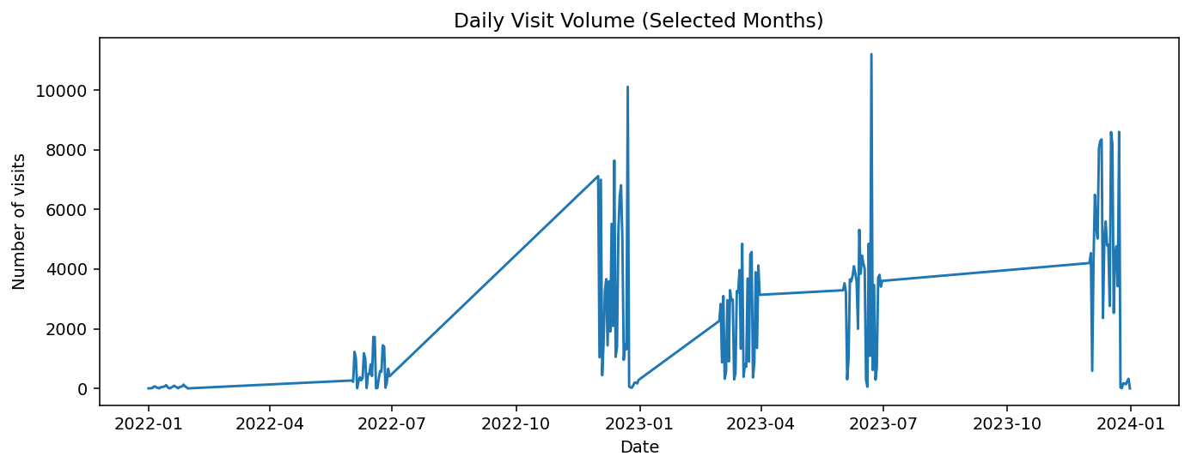
As shown in Figure 1, visitor demand is uneven rather than steady over time.
FIGURE 2 — Monthly Visits by Meeting Location
The Monthly Visits by Meeting Location stacked bar chart reveals that the White House (WH) consistently accounts for the majority of visits, while other locations such as OEOB, NEOB, and VPR contribute smaller but steady portions. This concentration highlights the importance of prioritizing space management and staffing at the primary White House location.
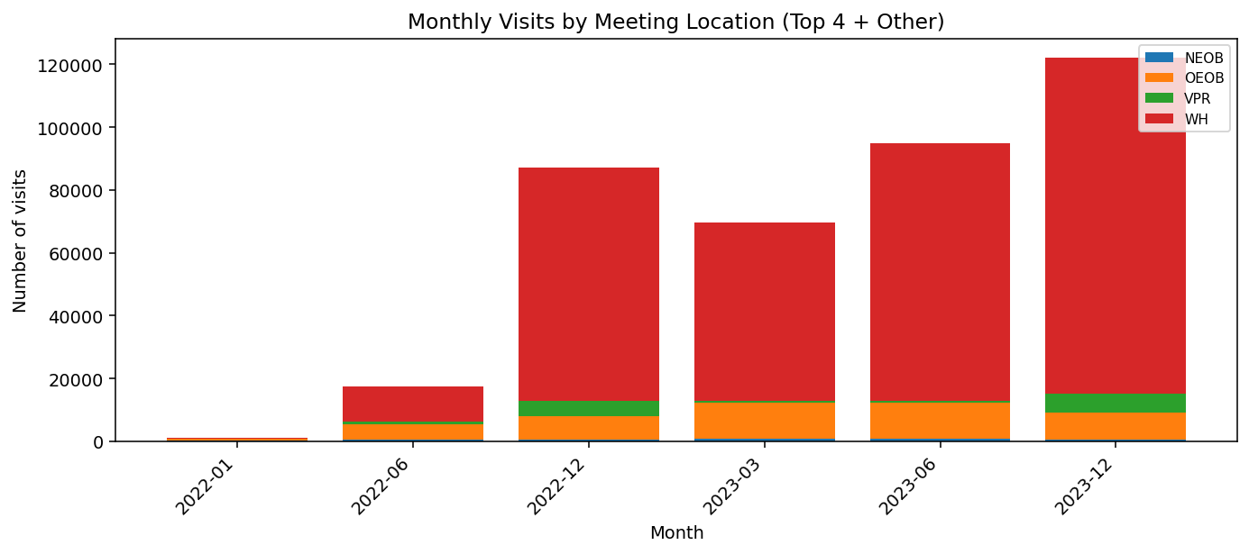
Figure 2 illustrates how visitor activity is concentrated in a small number of locations.

FIGURE 3 — Top 10 Meeting Rooms
Analysis at the room level shows that a small number of meeting rooms account for a disproportionately high number of visits. This concentration suggests that certain rooms experience consistently higher utilization and may require prioritized scheduling, maintenance, or staffing support.
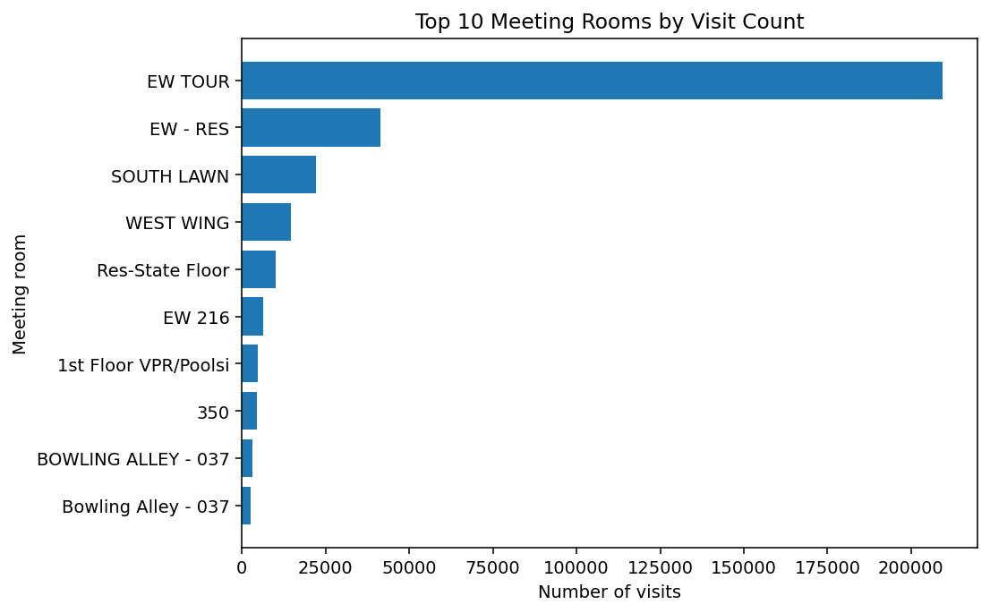
This pattern highlights opportunities to focus operational attention on the most frequently used spaces.

FIGURE 4 — Visit Size Over Time
The Visit Size Over Time scatterplot shows that most visits involve small groups, but there are notable outliers with very large group sizes. These outliers represent potential operational risks if not planned for in advance.
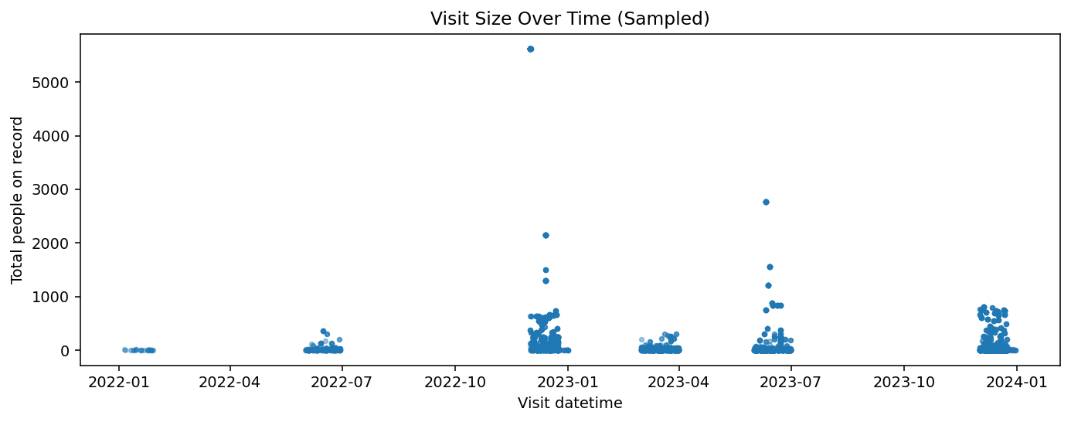
These large outliers represent potential operational risk if not planned for in advance.

FIGURE 5 — Cumulative Visits Over Time
The Cumulative Visits Over Time step chart demonstrates sharp increases during specific periods, reinforcing the idea that visitor activity is not evenly distributed over time. Instead, demand accelerates in waves, which supports the need for dynamic rather than static resource planning.
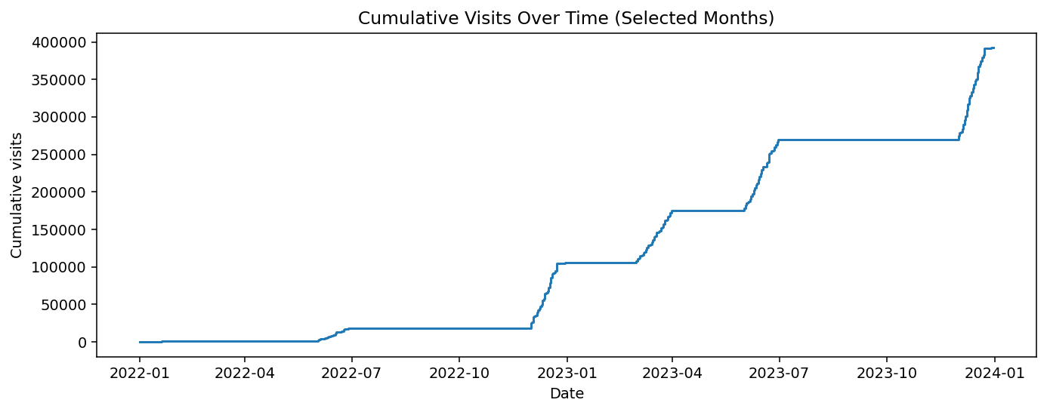
This reinforces the need for flexible, demand-based staffing strategies.
FIGURE 6 — Visits by Day of Week
Finally, the Visits by Day of Week column chart shows higher visit volumes toward the end of the week, particularly on Thursday and Friday, with noticeably lower activity on weekends. This pattern suggests that staffing schedules could be optimized by reallocating resources toward late-week peak days.
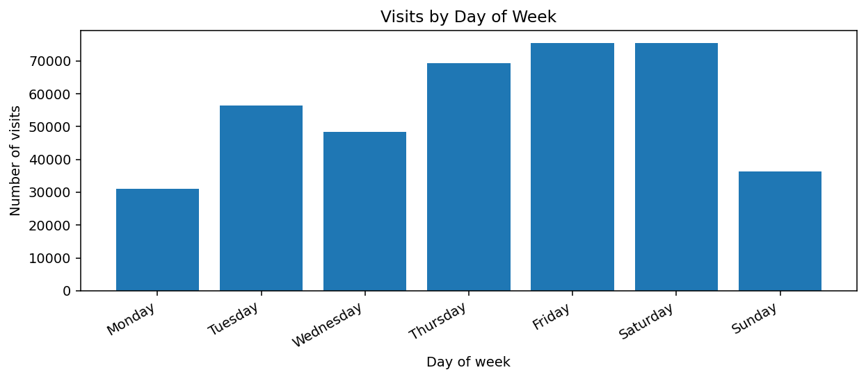
This finding directly supports reallocating staffing resources toward late-week demand.

Design Considerations and Ethics
Gestalt principles such as similarity, alignment, and proximity were applied to ensure consistency across visuals and to guide the viewer’s attention. All data transformations, including filtering records without valid visit timestamps, were documented and applied consistently. The analysis uses only aggregated visit data and avoids any identification of individuals, mitigating privacy and ethical concerns.

Conclusion
This visual analysis of the White House visitor logs demonstrates that visitor activity is highly variable across time, location, and visit size, with demand clustering around specific periods rather than occurring evenly. The daily visit volume and cumulative visit trends reveal sharp spikes and waves of activity, indicating that static staffing and scheduling models may be insufficient to support operational needs during peak periods. These findings underscore the importance of data-informed planning in environments where capacity, security, and coordination are critical.
The location-based analysis further shows that the majority of visitor activity is concentrated within the White House itself, while other meeting locations contribute smaller but consistent volumes. This concentration highlights the need to prioritize staffing, security coverage, and space management in high-traffic facilities. Additionally, the variability observed in visit sizes, including occasional large group visits, presents potential operational and logistical risks if not anticipated in advance.
Weekly visitation patterns provide actionable insight for workforce optimization. Higher visit volumes toward the end of the workweek, particularly on Thursdays and Fridays, suggest opportunities to redistribute staffing resources to better match demand. Conversely, lower activity on weekends indicates potential flexibility for maintenance, training, or reduced staffing levels without compromising operational effectiveness.
Overall, this project illustrates how thoughtfully designed visualizations can transform complex administrative data into clear, actionable insights. By aligning staffing strategies and room scheduling policies with empirically observed patterns, operational stakeholders can improve efficiency, reduce bottlenecks, and enhance the overall visitor experience. The approach demonstrated in this analysis reinforces the value of data visualization as a decision-support tool, particularly in high-stakes operational environments.

